**Lab 7 Name _________________________________________**

**MCSE 1 User Accounts**

**Objective:**

In this lab you will:

- investigate what rights a limited local account possesses

- create domain accounts

**Procedure:**

_x__ Start Ottawa (Windows 7) and Saskatoon (Windows 10). Log into the Administrator’s account on each computer.

_x__ Make sure you can ping by IP address between the two computers.

We want to see how restricted a limited account is.

**Ottawa:**

__x_ Create a local user account called **Jim Brown**.

__x_ Log in as Jim.

__x_ Try performing the following tasks:

1. change the time

2. change the time zone

3. create a new group

**1. Capture the message that appears when Jim tries to create a new group.**

4. create a new user

5. turn the firewall on or off (after changing the firewall open it again

to see if the change you made is still there or if it reverted

back to its original setting).

6. change the IP address on the NIC

**2. Capture the message that appears when Jim tries to change the IP address on the NIC.**

__x_ Create a folder in the root of C:\. Use your last name as the name of the folder.

7. Share the folder. To do this, right-click on the folder and select **Properties**. Click on the **Sharing** tab. Click on the **Advanced Sharing** button. Click on **Share this folder**. Click on **OK**.

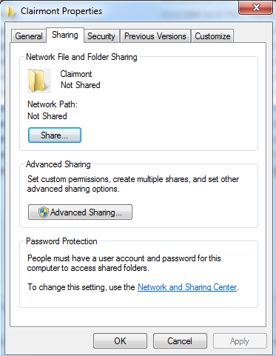

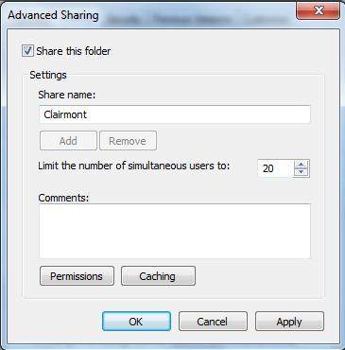

Fig. 1 Sharing a folder

**3. Capture the message that appears when Jim tries to share a folder.**

**4. Which of the 7 items mentioned above can Jim perform?**

Let’s see what rights a standard account has. This time we will use Windows 10

on Saskatoon to test the rights.

**Saskatoon:**

__x_ Create a new local user account called **Carl Hubby**.

We want this account to be a **standard** account so we have to add the user to

the **power user** group. Follow the steps in figure 2.

__x_ Right-click on Carl’s account and select **Properties**. Click on the **Member Of** tab. Add the **power users** group.

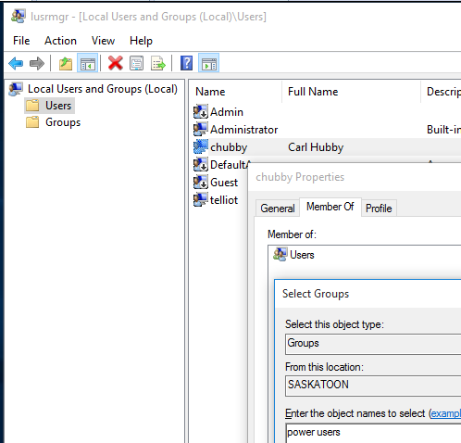

Fig. 2 Turning Carl’s account into a standard account

**5. Capture the “Members Of” page showing the groups Carl belongs to.**

_x__ Log out of the administrator’s account and log back in as Carl.

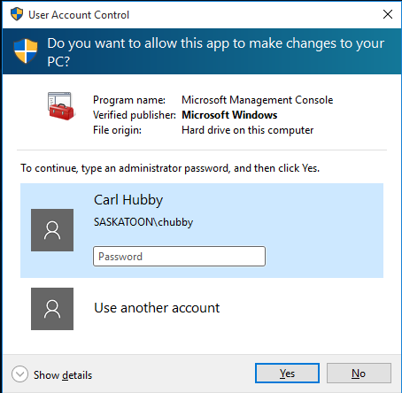

__x_ Try performing the following tasks:

1. change the time

2. change the time zone

3. create a new group

You will find that when you run **lusrmgr.msc**

figure 3 appears. You do not have enough

permissions to access the users and groups

utility. Figure 3 is asking you to enter the

credentials of the administrator. Click on **No** Fig. 3 Carl can’t run **lusrmgr**

to close the window.

4. create a new user

5. turn the firewall on or off (after changing the firewall open it again

to see if the change you made is still there or if it reverted

back to its original setting).

6. change the IP address on the NIC

__x_ Create a folder in the root of C:\. Use your last name as the name of the folder.

7. Share the folder.

**6. Which of the 7 items mentioned above can Carl perform?**

In the old days, (with Windows XP) the standard account could perform almost all

of the 7 tasks while the limited account could perform only the ones you

discovered when you tried them. The later operating systems removed the extra

rights from the standard account so now the limited account and the standard

account are the same.

**Creating a domain account**

In a client server network, the accounts are created on a domain controller and

users log into the domain with their domain account.

In the last lab you turned Calgary into a domain controller. Let’s create an

account on Calgary.

**Calgary:**

__x_ Get Calgary running. Log in as the Administrator.

__x_ Click on Start and Administrative Tools. Double-click on **Active Directory Users and Computers**.

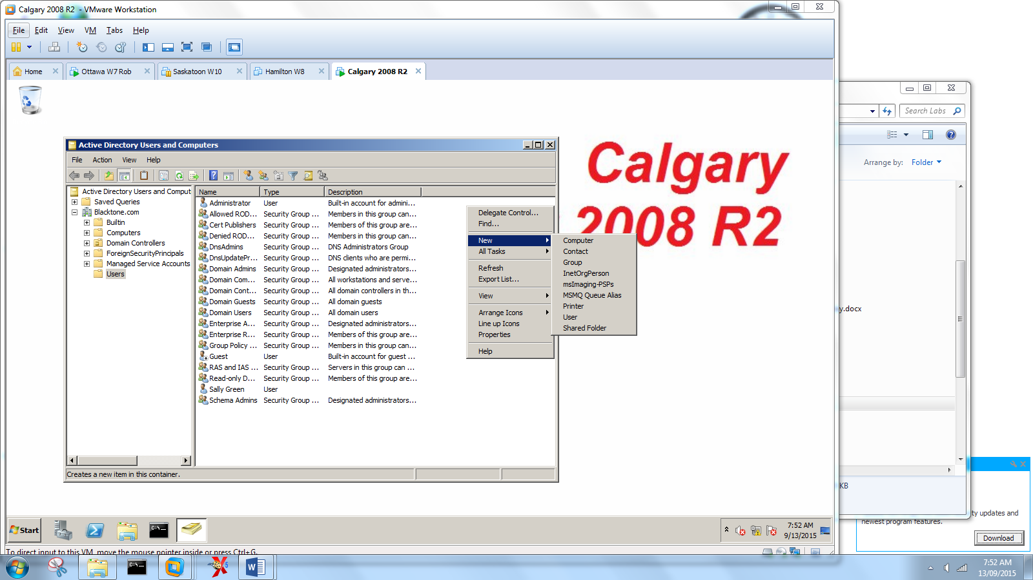

Fig. 4 Creating a domain account

__x_ In figure 4, click on **Users** in the left-hand pane and then right-click on the right-hand pane. Select **New** then **User**.

__x_ Create the user shown in figure 5.

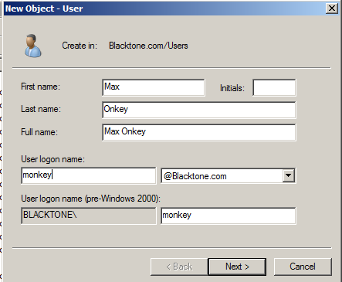

Fig. 5 Creating a new domain account

__x_ Use the regular password we use for all our users. Set the account so the password never expires.

__x_ When the user account is created, right-click on the new account in the right-hand pane and select properties. Then click on the Account tab.

**7. Capture the “Account” page.**

**Joining a domain**

Let’s try logging into the new domain account.

**Ottawa:**

_x__ Log out of the account you are currently logged into.

__x_ Try to log into Max’s domain account.

The only accounts that show up are the local accounts. You can’t access a

domain account. We must join the workstations to the domain so we can log into

domain accounts.

**Calgary:**

__x_ In **Active Directory Users and Computers** click on **Computers**.

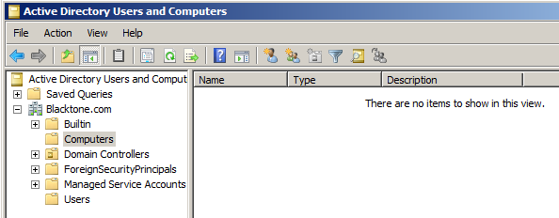

Fig. 6 The **Computers** container is empty

**Ottawa:**

Let’s join Ottawa to the domain.

__x_ Log in as the administrator. Configure the NIC so Calgary is the preferred DNS server.

__x_ Make sure you can ping between the 3 computers to ensure you have connectivity.

__x_ Click on **Start**, right-click on **Computer** and select **Properties**.

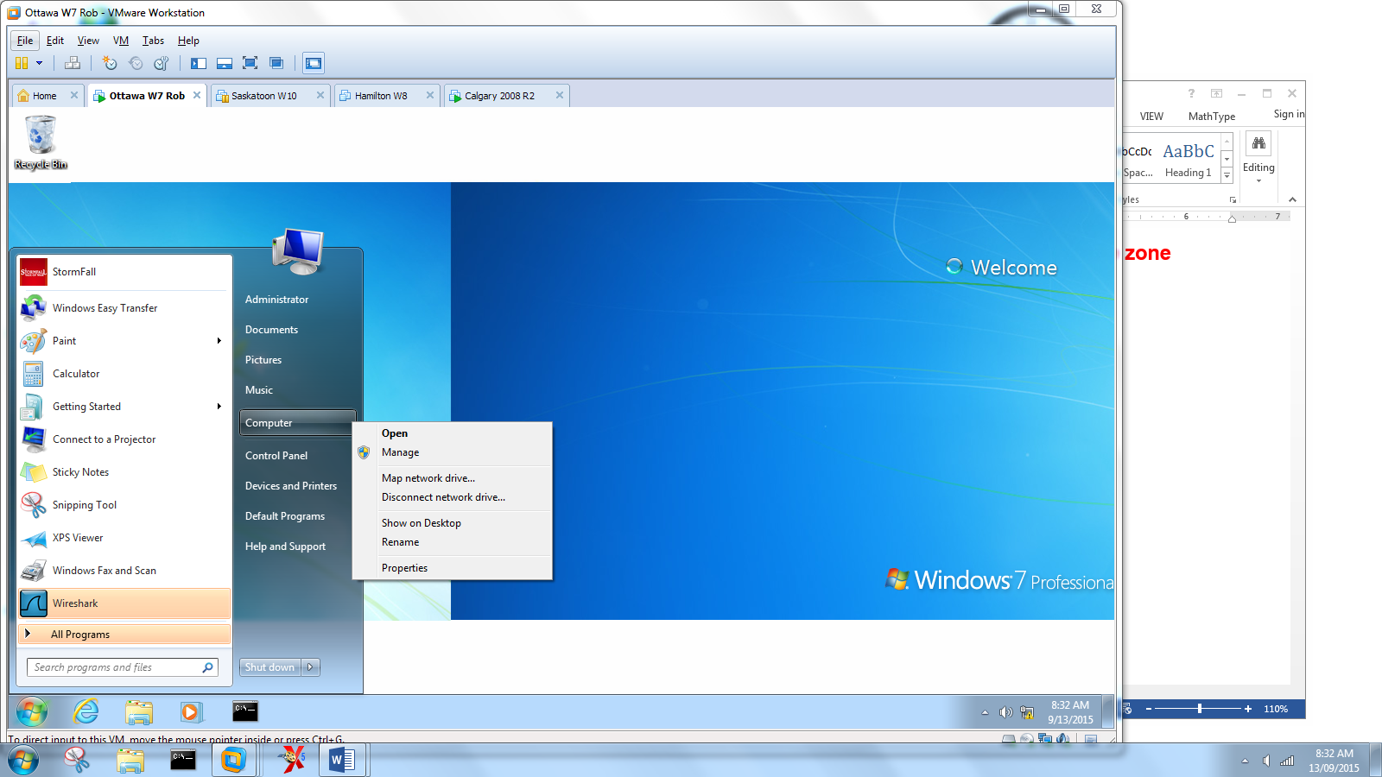

Fig. 7 Joining Ottawa to the Blacktone domain

__x_ In figure 8, click on **Advanced system settings**. Select the **Computer Name** tab. Click on the **Change** button**.** Select **Domain** and enter the domain name for Calgary; **Blacktone.com**. Click on **OK**.

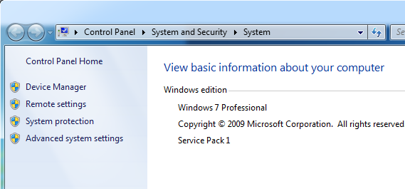

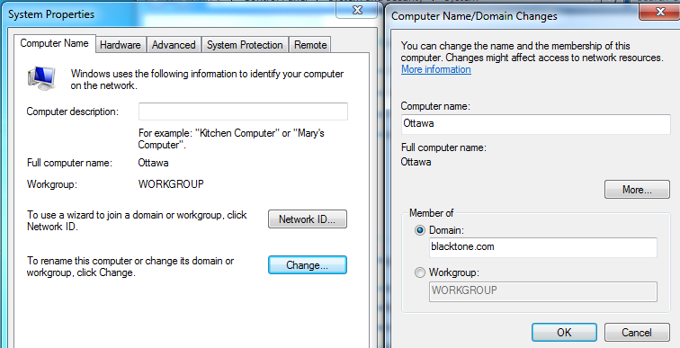

Fig. 8 Joining Ottawa to the Blacktone domain

A window will appear that asks you to log in. This is Calgary asking for the

credentials of a domain user that has permission to join computers to the

domain.

__x_ Supply the administrator’s credentials.

A welcome screen should appear letting you know Ottawa has joined the

domain.

__x_ Close the windows and restart Ottawa.

__x_ Once Ottawa has rebooted, try to log in to Max’s domain account. To do this, select **Switch user** and then enter **Blacktone\monkey**.

__x_ Once you have logged in, open a DOS window and type **ipconfig /all**.

**8. Capture the DOS window. Make sure the prompt says “c:\users\monkey>”. Make sure the Primary DNS suffix “Blacktone.com” is visible.**

**Saskatoon:**

Let’s join Saskatoon to the domain.

_x__ Click on **Start** and select the **This PC** tile. Select properties.

All the rest of the steps are the same as they were for Ottawa.

_x__ Once Saskatoon has joined the domain, restart Saskatoon.

__x_ When Saskatoon reboots, log into Max’s account.

_x__ Open a DOS window and type **ipconfig /all**.

**9. Capture the DOS window. Make sure the prompt says “c:\users\monkey>”. Make sure the Primary DNS suffix “Blacktone.com” is visible.**

By default, a user can be logged into her domain account on multiple

workstations. Quite often the administrator will configure the network so the user

can only log in from 1 workstation at a time.

**Calgary:**

When a computer joins a domain, an account is created in Active Directory for

the computer. The default container in Active Directory where all computers

joined to the domain show up, is the **Computers** container. Let’s see if the

Ottawa and Saskatoon computer accounts were created.

_x__ In **Active Directory Users and Computers** click on the **Computers** container in the left-hand pane.

**10. Capture the contents of the “Computers” container showing the two accounts for Ottawa and Saskatoon.**

One last thing…. Only the administrator can log into a server. Let’s try it.

_x__ Log out of Calgary and try to log into Max’s account.

**11. Capture the error message that appears when Max tries to log on to Calgary.**

That’s it for another lab. Shut down the virtual machines.

[](http://www.google.ca/url?sa=i&rct=j&q=&esrc=s&frm=1&source=images&cd=&cad=rja&docid=MWmSEOL6tT31vM&tbnid=x3aUtkplBMEcZM:&ved=0CAUQjRw&url=http://www.sodahead.com/living/travis-county-district-attorney-rosemary-lehmberg-said-she-does-not-plan-to-step-down-following-her/question-3654191/&ei=cReZUbi6I43TqQGW7oG4CA&bvm=bv.46751780,d.aWc&psig=AFQjCNE3ZY5ooZLAdzaM_QPNVHPRPeaSsQ&ust=1369073770202726)

***You probably have too!***